GITHUB DOCUMENT 1
- Create a GitHub account.
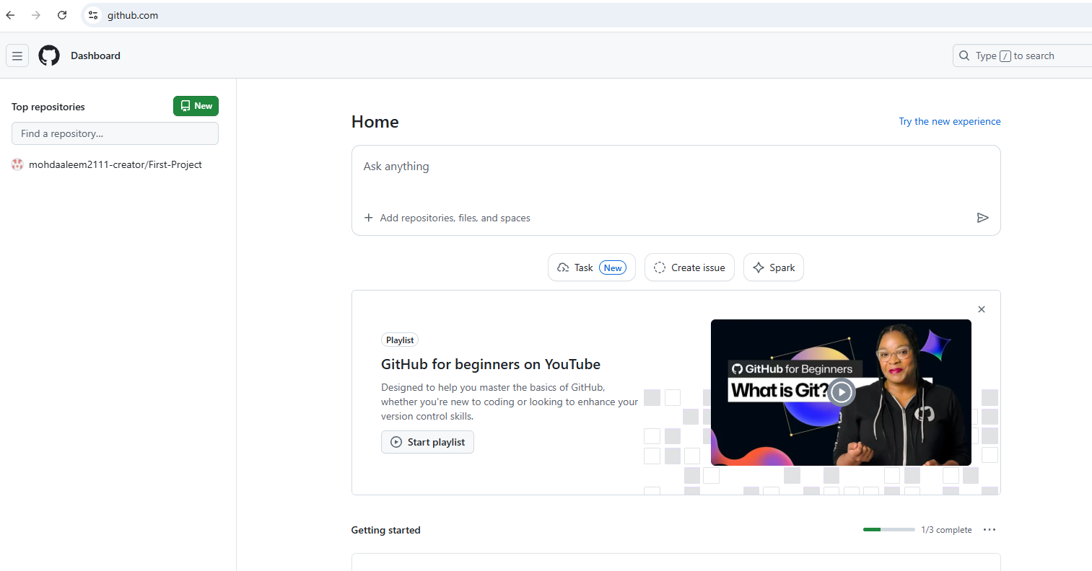

- Set up MFA (Multi-Factor Authentication) for the GitHub account using a mobile
app.
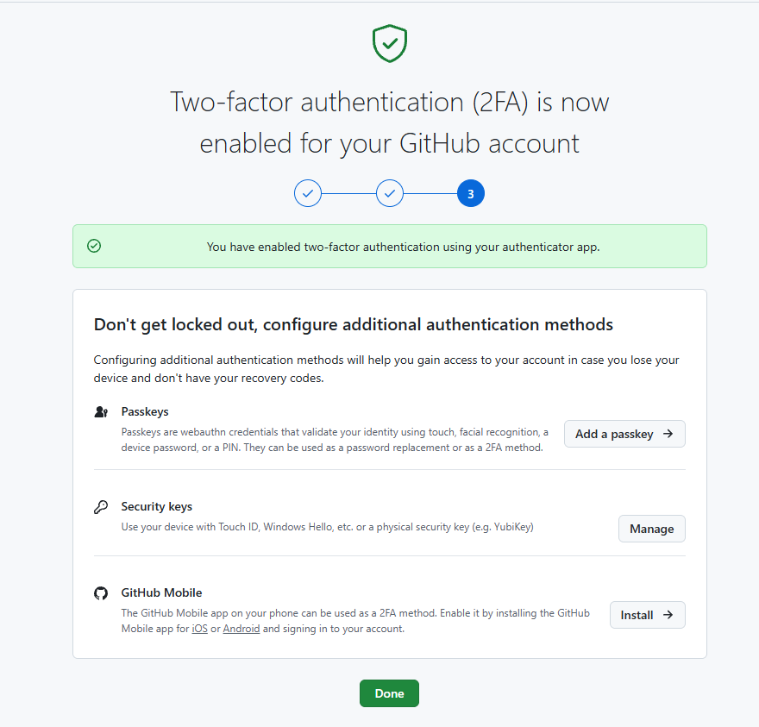
- Execute all commands shown in the video.

1.how to initialised repository to github.
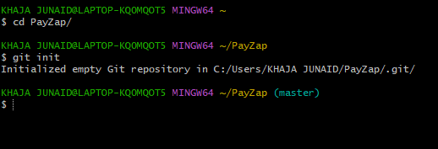

2.check status of git
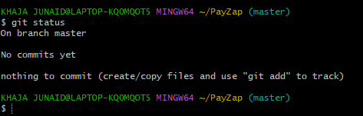
- To check git configuration.
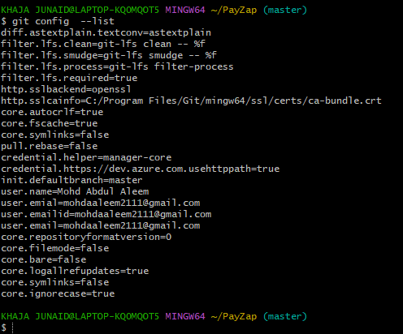

- To add user name email and check the user added or not.
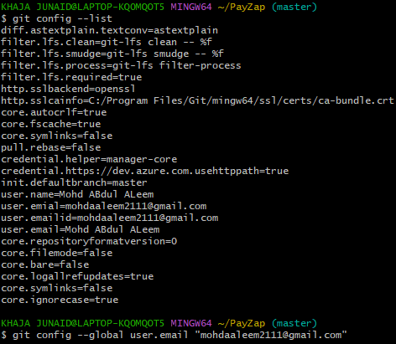

- Add a file and move a file to tracking area of git.
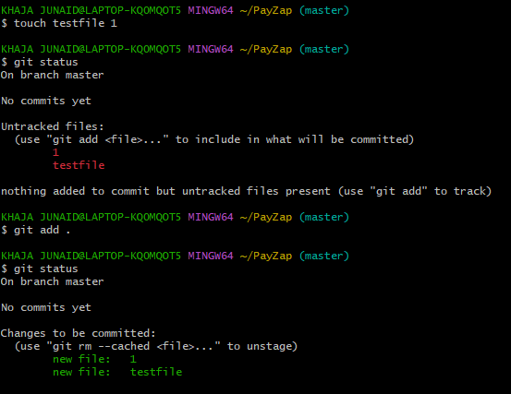
- Commit the changes our local repository and add commit message and check commit message in git log.
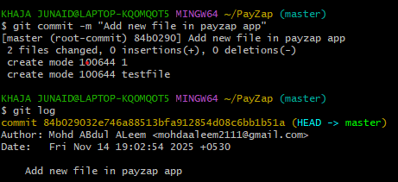

- Create a communication between local mechine repository in centralised reposirory github webpage.

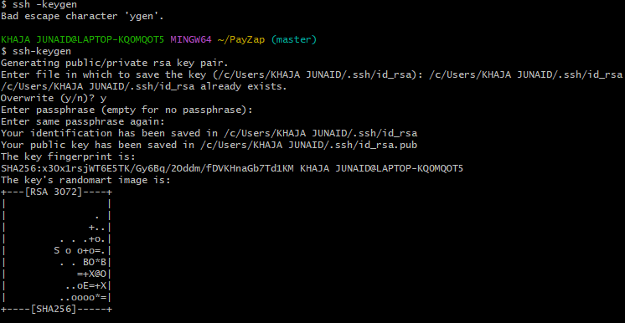
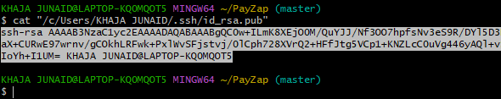
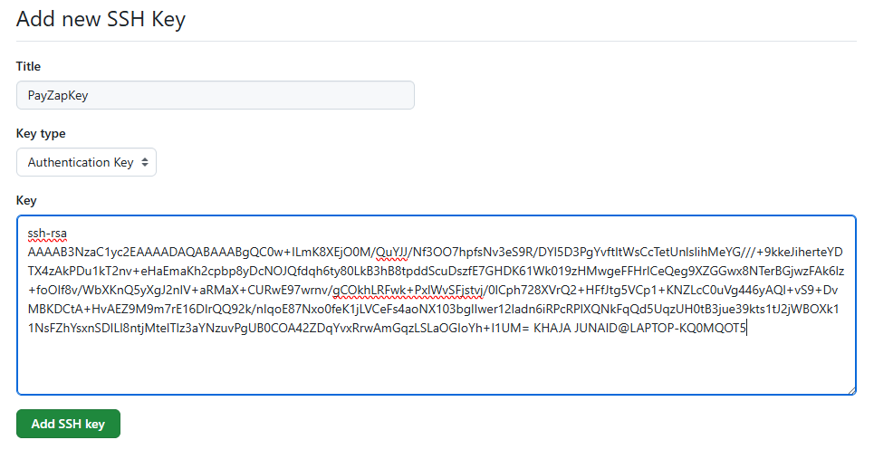
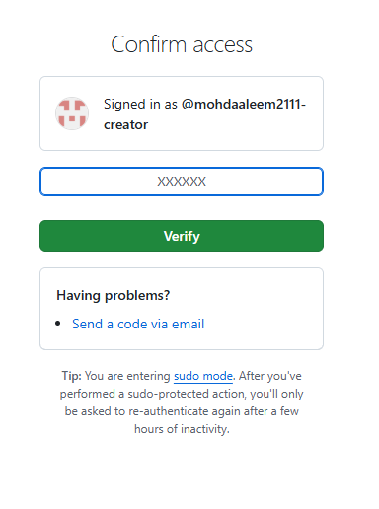
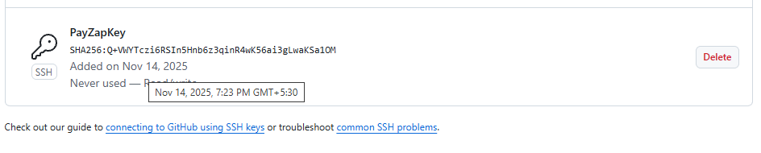

- Delete a file from local mechine and update in github centralised repository.
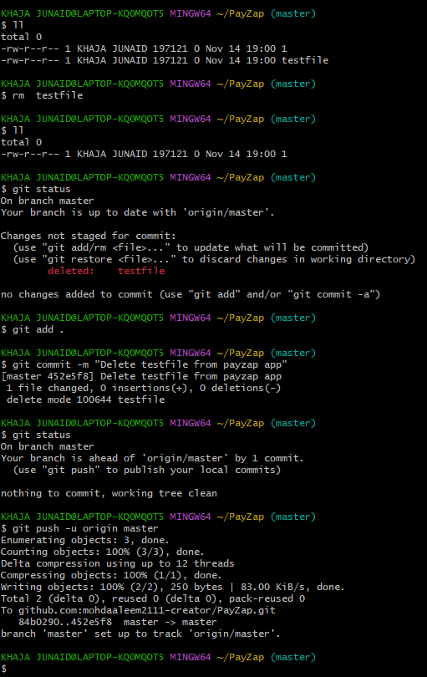

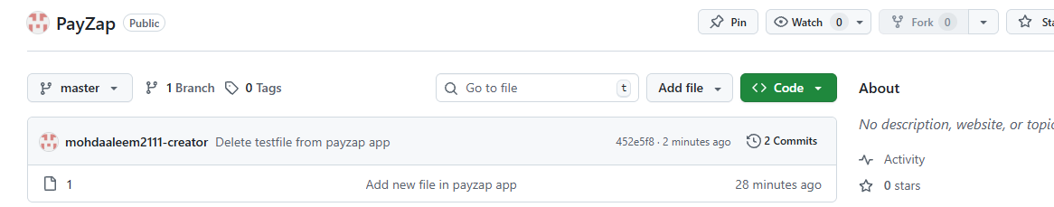

- How to add a new file from github repository to our local mechine repository
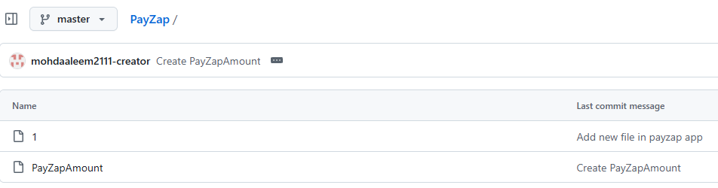
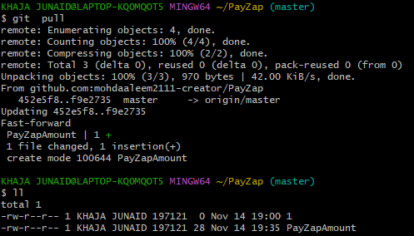

- To download complete project repository from github to our local mechine.
